

Name : Kiroshma Rajentheran

Login ID : R03412918@oasis-portal.com

Course title : Executive Diploma in Business and Hospitality Management

Subject Code : BHM04 Tourism & Hospitality

Submitted date: 11th Sept 2017

**Table of Contents**

|  |  |  |
| --- | --- | --- |
| **No** | **Details** | **Page** |
| 1 | Executive Summary | 2 |
| 2 | Introduction | 3 |
| 3 | Assignment Question |  |
|  | Questions 1 | 4,5,6 |
|  | Questions 2 | 7,8 |
|  | Questions 3 | 9,10 |
|  | Questions 4 | 11,12 |
| 4 | Conclusion | 13 |
| 5 | References | 14 |

**Executive Summary**

In this assignment, I’m going to present my understanding about the principal of tourism within hospitality management operations. In the first part of this assignment, I need to defined and describe about the tourism and hospitality with some relevant examples. Besides that, I also got explain about hospitality industry in a brief formal and there also have an explanation based on my understanding in an essay form. In second part, I am required define about tourism based on my understanding and also an explanation about the types of tourism categories in detail with some relevant example in a brief formal. There also provide a clear explanation about the definition of tourism. Moved to the third part, I need to describe about the concept of lodging and accommodation in a hospitality industry. In the last part based on my understanding, I need to explain about the entertainment industry in hospitality management including with some examples of entertainment and case study on entertainment in hospitality.

**Introduction**

Tourism is the movement of people to different countries or outsides places for personal or business purposes. These people are called as tourists. The purposes of their trip can be for business, leisure, or for personal reasons other than to be employed in the country. There are three basic forms of tourisms such as domestic tourism, inbound tourism, and outbound tourism. The tourism also cans categories to different types of tourism. There are leisure, culture, religious, family, health, sports, educational, business, and alternative tourism which be the purposes of tourists to visit the country.

Hospitality is the act of kindness in welcoming and looking the guests mainly in food, drink, and accommodation. The characteristics of hospitality is receiving and treating guests and visitor in patient, friendly and generous way. The organizations that provides for guests and visitor are food, drink and entertainment. Hospitality also refers to the relationship process between a guests and a host. Hospitality industry is the range of businesses that provide services and facilities such as accommodation, food and beverage, entertainment and so on.

The relationship between the hospitality industry and tourism are as we seen, the hospitality industry includes hotels and restaurants, as well as many other types of organizations or institutions that offer food, drink, shelter and other related services. These services are offered not only to people away from home, but also a local guest. The objectives are making the guests feel welcome, making things work for the guests and making sure that operation will continue to provide service.

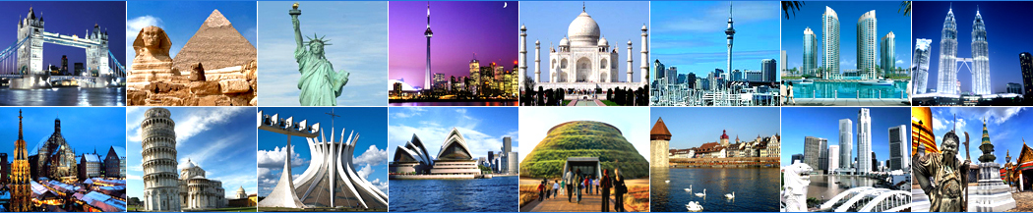

**The tourism world**

**Assignment Questions**

**Question 1**

**Define the tourism and hospitality.**

Tourism is the activity or practice to people for touring especially to having pleasure. Tourism also can be said as visiting different places and country for sight-seeing. Tourism is also the industry which provides information, accommodations, transportation and other service to tourists. The reason why people travel in their life is for relaxation, fun, entertainment, to gain knowledge by different types of culture and food. There also have some people visiting their friends and relatives.

Hospitality is the act of being friendly and treatment to welcoming guests and visitors. The characteristics of hospitality is receiving and treating guests and visitor in patient, friendly and generous way. The organizations that provides for guests and visitor are food, drink and entertainment.

**Explain your understanding about hospitality industry**

The hospitality industry is a business industry that provides all services to its customers such as food and beverages services, accommodation services, travel and tourism, entertainment services and also timeshare services. The hospitality industry also provides a challenging job opportunity around the world with free work time, encouraging income and extensive travel opportunities.

There are five different sectors in hospitality industry:

**# Food and beverage**

The food and beverage industry also known as the food service industry consists of businesses that prepare food for customers. This is an important sector among this 5 different sector of the hospitality industry. Food and beverage sector given importance for a good reasons. For an example, food and beverage department is responsible for maintaining high quality of food and service, food coating. There can be list up the food service categorize such as quick-service establishments, catering businesses, full-service restaurants, food management, food presentation, beverages and restaurant management. If we can manage and maintain the food and beverages sector and quality representation of food so that customers will come again to eat at our place. The examples of the Food & Beverage sectors are restaurants & and hawker centers in Singapore.

**# Lodging – accommodation**

Accommodation is a large sector of the hospitality industry. Hotels, bed and breakfast enterprises and other places offering lodging represent a large part of the hospitality industry. Types of businesses run the collection from extravagant resorts to hotels and campgrounds. Your business focus on providing lodging should integrate comfort, efficiency and attentive customer service as its foundation. Travelers value thoughtful treatment and simple useful. When they fell appreciated, enjoy and catered, the guests will tell others about their experience and may become a repeat customers.

**# Travel and tourism**

Travel and tourism industry is a huge sector of the hospitality industry with some important players across the world. There are trains, airlines, cruise ships, and several crew members in their services. When we talk about travel and tourism, it is not mean that people travel for fun and entertainment. People also travel across the world for businesses, education, entertainment, and holidays and also for many other things.

**# Entertainment industry**

Entertainment is a significant part of our travel these days. If our travelling experience shortage fun and entertainment then we might mot ne able to enjoy our time to having enough. So, for the successful running of a hospitality business, it is important to in amount of money gathered in many entertainment activities as possible. The activities that can upgrade our experience when it comes to entertainment are marinas, sports and gaming, cruise, night club, and bars.

**# Time share**

Timeshare is a surface which massively important in hospitality industry. In this plan, people own the rights to a place for a specific time period during the year. Time share also gives us a number of subjects to choose our choices and all to enjoy the opportunity by buying a part of opportunity or getting into a membership plan.

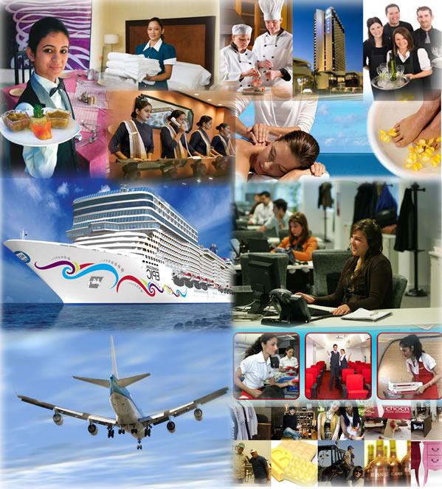

Sector of hospitality industry

**Questions 2**

**Brief on different type of tourism categories.**

There are many types of tourism categories. For an example, leisure, business, and special interest. Based on the types of tourism, tourism can category into the following:

**# Leisure tourism**

Leisure tourism is also called as pleasure tourism or holiday tourism. It is a type of tourism when a type of tourism when a person goes on holiday and does not travel on business. Leisure travellers look for sun, sea and sand. They want to go sunbathing, swimming, and diving. So this kind of travellers to go sea resorts or holiday camps and stay at resort hotels.

**# Culture tourism**

Culture tourism can let tourists to learn the culture of a particular country or region. People who are interested to know about the foreign lands and their culture. Culture is the main factor which attracts tourists to visit that place. Tourists can know the foreign culture by looking forward to their life style, attires, festivals, religions and culinary delights.

**# Religious tourism**

Religious tourism is referred as faith tourism, is a type of tourism, where people travel individually or in groups for pilgrimage, missionary, or leisure (fellowship) purposes. For example, the world’s largest form of mass religious tourism takes place at the annual Haji pilgrimage in Mecca, Saudi Arabia.

**# Family tourism**

Family tourism is an activity that cans together the family unit and their participation by tourism activities. There are some families who visit their friends or relatives by the tourism activities. By visiting, they also will have a good time and the attractions of the place.

**# Alternative tourism**

Alternative tourism is a tourism which we can visit for the natural place or traditional place to share our services of the local people. It also will be special interest tourism because it is a various type’s tourism. Example is waterfall and zoo.

**# Business tourism**

The business tourism is the main motive for travel to work purposes. Tourists will visit the particular place for different reasons for work purposes. Example attending meeting, conferences, meeting clients and more.

**# Educational tourism**

Educational tourism increases because of the growing popularity of gaining knowledge. In this tourism also, there are some programs to let the students to learn the culture and also about the country because it’s visiting to another country to learning.

**# Health tourism**

Health tourism is also can called as medical tourism. People travelling for some countries because of their health to improve or rebuild their health. There are some tourists going for treatment because of their health purposes.

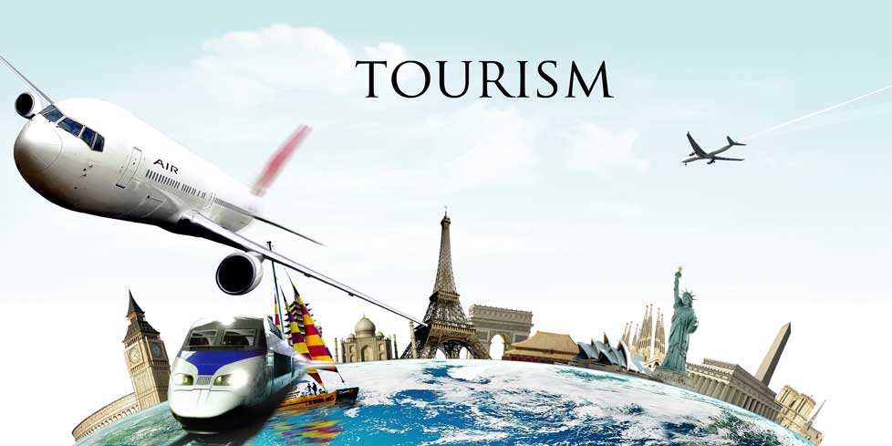

**Define tourism**

Tourism is travelling for another place to having pleasure for a long duration. It’ also can let tourists to learn the different culture and also about the country. Tourists normally will travel for a different purposes such as leisure, sport, health, educational, culture and so on. People also will travel for having a sight-seeing by visiting different country.

**Questions 3**

**Describe the lodging accommodation and types of hotel accommodation.**

Lodging accommodation is a place to people live or stay especially on holiday or for students at collage. The types of accommodation such as bed breakfast, backpacker hostel, guest house and so on. For an example:

**# Bed breakfast**

A bed and breakfast is a private home in where guest can stay for a night in private room which is providing breakfast and other meals by the arrangement.

**# Backpacker**

Backpacker is a hostel to the people stay in budget traveller in a sharing room and also providing light food by addition in the room rate.

**# Guest house**

A guest house is a private house to people stay for the dedicated and exclusive use of guest accommodation.

**Types of hotel accommodation**

**# Motels**

They are designed for overnight stays for car travellers often with very basic facilities. The room usually has direct access to open a parking lot. They are often smaller than hotels.

**# Resorts hotels**

These hotels are located in sometimes remote settings. Guests travel long distance to resorts. Usually they tend to stay longer. Resorts typically provide a variety of food and beverage.

**# Casino hotels**

They are gambling operations which are the major revenue centers. They also provide the live entertainment. A wide variety of hotels service including fine, casual dining and shopping.

**# Extended - stay hotels**

These cater for guests who stay for an extended period. They usually offer full kitchen facilities, shopping services, business services and limited housekeeping services.

**# All – suite hotels**

The guest’s rooms in these hotels are larger than normal hotels rooms, with separate areas for working, sleeping, and relaxing. A living area is typically separated from the bedroom, and some properties offer a kitchen set-up in the rooms.

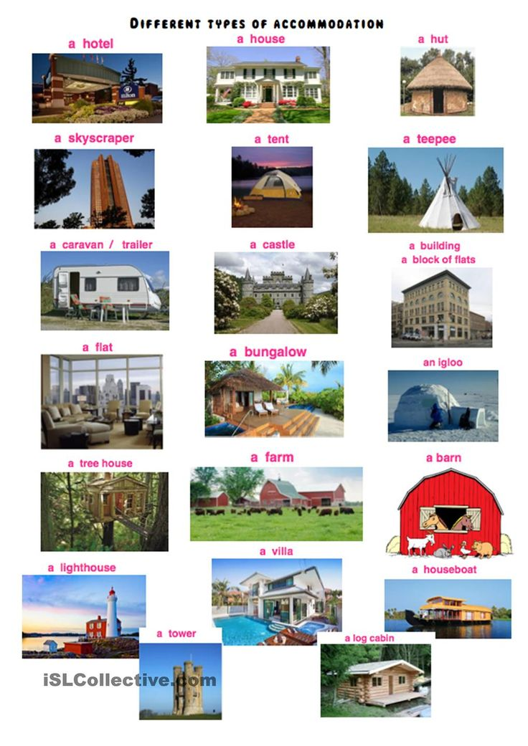

**Questions 4**

**Explain the significant of entertainment in this industry.**

Entertainment is forms of activities that take away peoples stress basically come from work or school and give them properly amusement to relax. If our travelling experience shortage fun and entertainment then we might mot ne able to enjoy our time to having enough. So, for the successful running of a hospitality business, it is important to in amount of money gathered in many entertainment activities as possible. Entertainment industry is important as it brings people together with the bond. It diverts people’s attention from their leisure time. Usually, entertainment is fun, enjoyable and pleasurable. Entertainment can take various forms including music, drama, storytelling, movie, sports, dance and traditional performances.

There are some entertainment places can be given:

# Night clubs

Night club is an entertainment places which serves alcoholic beverages that usually operates late into the night. It’s can be entertainment because of the inclusion of a stage for live music, one or more dance floor areas.

# Casino

Casino is a facility which house and accommodation certain types of gaming activities. Some of the casinos are also known for hosting live entertainment events such as comedy, concerts and sporting events

# Cruise

Cruise is the place people spend their days on luxury ships which sail across the blue oceans under the clear sky.

# Bars

Bars are the place to people sitting around a table and having couple of drinks with friends for refreshing experience. This also an entertainment part to people to having a good time.

# Marinas

Marinas are the popular place to go when it comes party or celebrating. There will be lot of fun and entertainment where we can dance, play games, and enjoy our time.

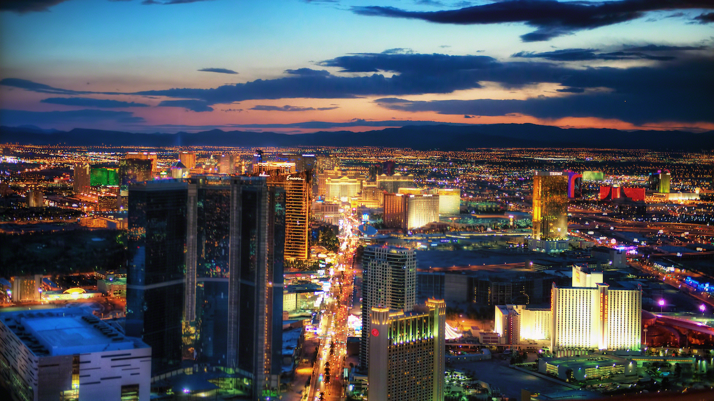

Entertainment places

**Conclusion**

In the conclusion of this assignment, I have learned about the definition of tourism and hospitality. As go to tourism part, I have learned about the types of tourism and the categories of tourism such as leisure, culture, health, educational and so on. Moreover, I also have learned about hospitality industry and also their sector such as accommodation, food and beverage and so on. Then, I also can gain my knowledge about the lodging accommodation and also the hotels accommodation. Furthermore, I also have about the meaning and significant of entertainment industry in hospitality industry. I also can get know about the places of entertainment industry such as bars, cruise, and marinas and so on.

**References**

[**https://www.google.com.sg/search?dcr=0&biw=1366&bih=662&tbm=isch&sa=1&q=entertainment+places+in+world&oq=entertainment+places+in+world&gs_l=psy-ab.3...39267.44484.0.44821.9.9.0.0.0.0.67.433.9.9.0....0...1.1.64.psy-ab..0.5.271...0j0i24k1.04lCTuiQA5U#imgrc=3yxpRO5q-6OioM**](https://www.google.com.sg/search?dcr=0&biw=1366&bih=662&tbm=isch&sa=1&q=entertainment+places+in+world&oq=entertainment+places+in+world&gs_l=psy-ab.3...39267.44484.0.44821.9.9.0.0.0.0.67.433.9.9.0....0...1.1.64.psy-ab..0.5.271...0j0i24k1.04lCTuiQA5U#imgrc=3yxpRO5q-6OioM)**:**

[**https://www.google.com.sg/search?dcr=0&tbm=isch&q=type+of+hotel+accommodation&spell=1&sa=X&ved=0ahUKEwifzaTpup3WAhXMvo8KHf2-AS0QvwUIIigA&biw=1366&bih=662&dpr=1#imgdii=HEbfy0xu86V9RM:&imgrc=8c9iJHVSSfyuRM**](https://www.google.com.sg/search?dcr=0&tbm=isch&q=type+of+hotel+accommodation&spell=1&sa=X&ved=0ahUKEwifzaTpup3WAhXMvo8KHf2-AS0QvwUIIigA&biw=1366&bih=662&dpr=1#imgdii=HEbfy0xu86V9RM:&imgrc=8c9iJHVSSfyuRM)**:**

[**http://www.dictionary.com/browse/tourism**](http://www.dictionary.com/browse/tourism)

[**http://www.dictionary.com/browse/hospitality**](http://www.dictionary.com/browse/hospitality)

[**https://www.safarinow.com/cms/accommadation-types/irie.aspx**](https://www.safarinow.com/cms/accommadation-types/irie.aspx)